DBMS Lab Assignment 7
Neeti Kurulkar
Concept of Triggers

Queries:
- Create Tables

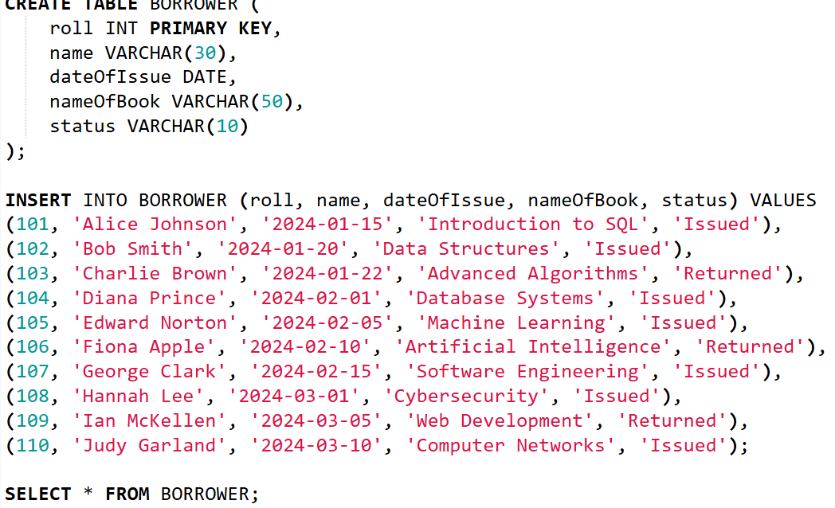

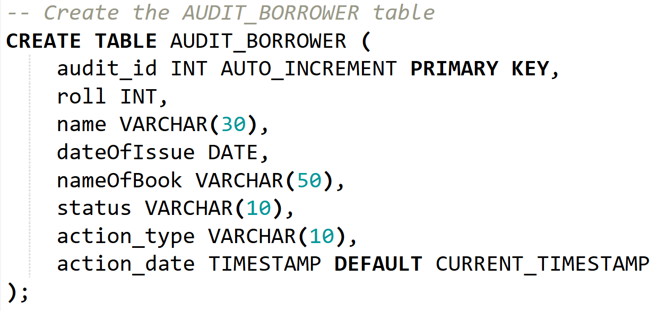

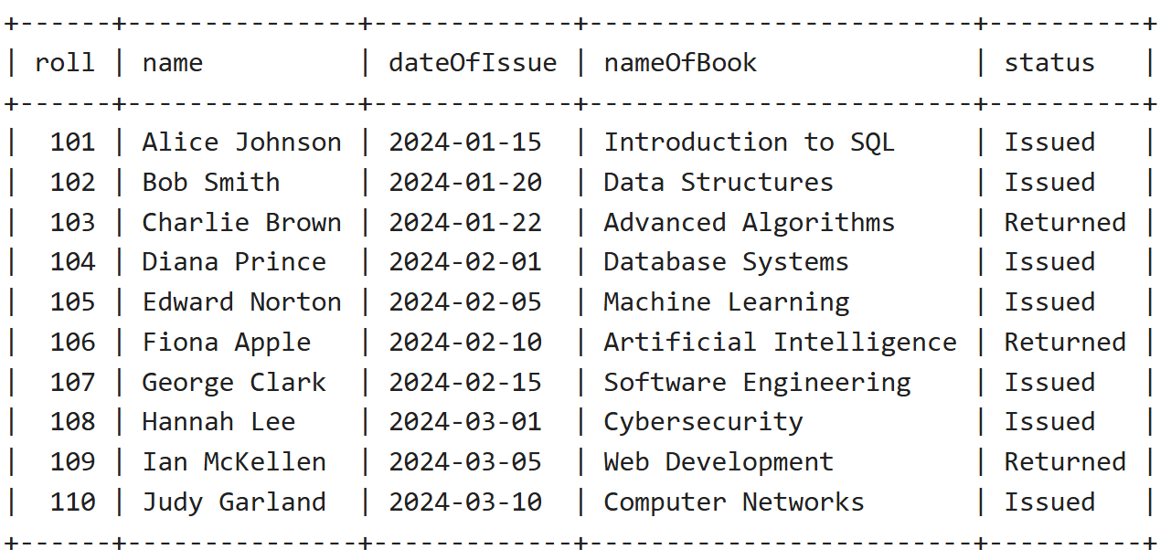
- Create Trigger for ‘Before Update’

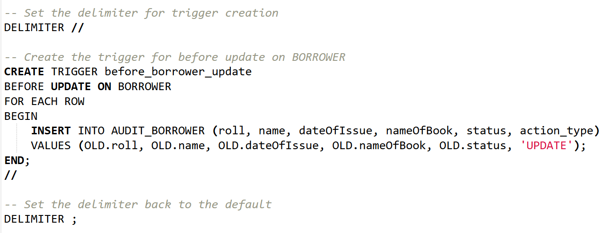

- Create Trigger for ‘Before Delete’

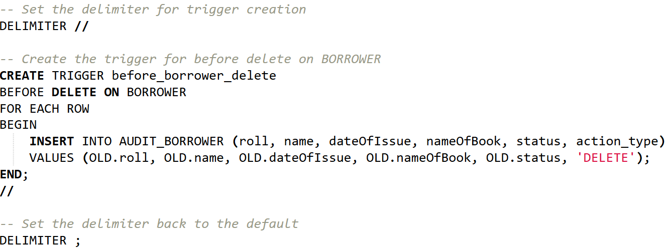

- Update and Delete records in ‘Borrower’ table

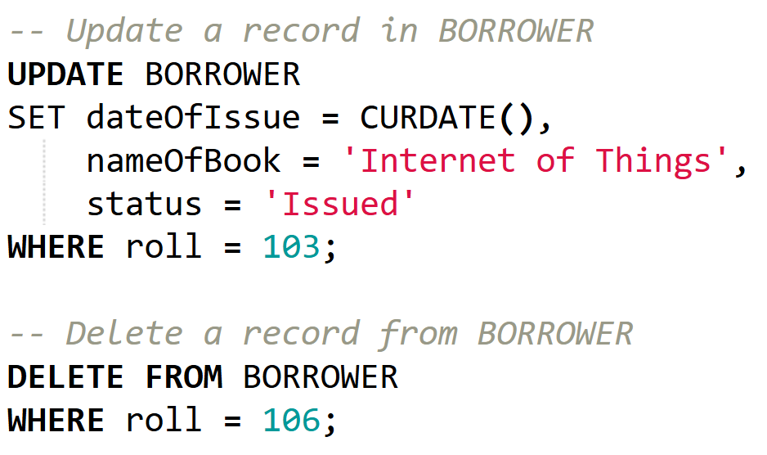
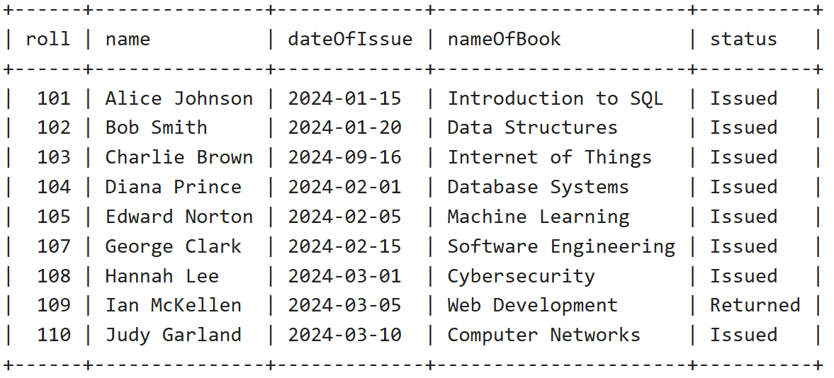

- Check Audit Table


